**TABLE OF CONTENTS**

1. **Application outline**
   1. Concept
   2. Project Scope
2. **Architecture and data model diagrams**
   1. **high-level architecture**
   2. **data model diagram**
   3. Conclusion
3. **Application outline**

**1.1 Concept**

Game Rating Web Application – RateThisGame

RateThisGame is a dynamic web application designed for users who wish to discover, rate, and review video games with minimal effort. Like rotten tomatoes and IMDB the web application will provide users with the ability to add their own opinion on a particular game. The users of the website will be able to make informed decisions based on the ratings of the games on the website. The rating system will work on a 5-star rating metric where users will be able to choose between 1 star and 5 stars. Users will be able to log in then add their own personal favourite games that will be rated by other users. Users will be required to log in via their email and passwords to leave a rating or a review.

**1.2 Project Scope**

**Key Features:**

* **Game Ratings and Reviews:** Rate and review games to help users make informed choices and uncover hidden gems.
* **Personalized Recommendations:** Discover new titles tailored to your preferences based on your ratings and interactions.
* **User-Generated Content:** Contribute to the gaming community by adding games and sharing your insights.
* **Community Engagement:** Connect with like-minded users, participate in discussions, and stay updated on gaming trends.

To help keep track of the project's development I’ve made a minimum viable product (MVP), I have created backlog to help prioritise what were the most key features needed for this web application to function as intended. Core functionality would look as follows:

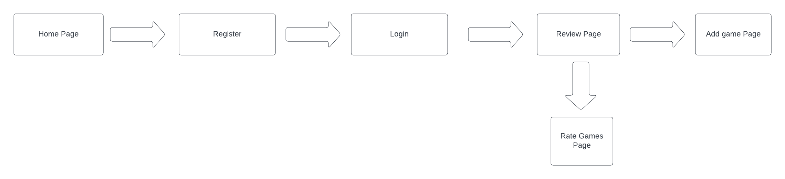

1. **Architecture and data model diagrams**

**2.1 High-level architecture diagram**

The diagram below shows all the components of the web application on each layer:

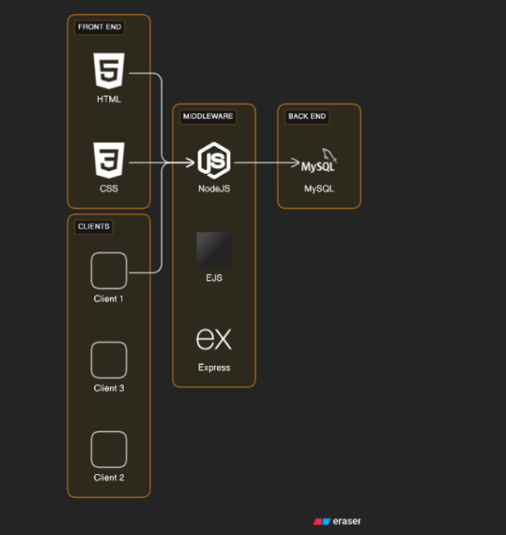

**2.2 Data Model Diagram**

The diagram below shows the entity relationship diagram and the column components for my web application.

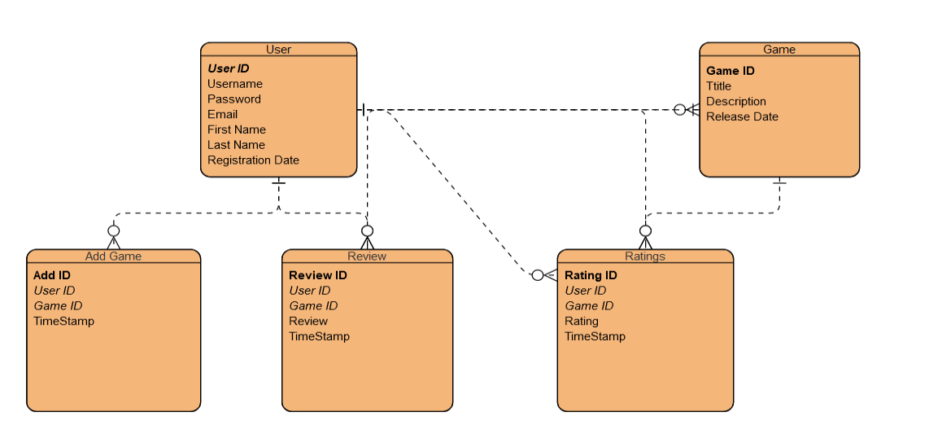

**2.3 Conclusion**

In summary, RateThisGame is a dynamic web application designed to provide users with informative discussions and insightful game reviews. With its user-friendly 5-star rating system and key features like the ability to review games and even a dark mode option on all pages will create a platform where gamers can make informed decisions and engage in meaningful discussions about their favourite games.